1. What status code is returned for a successful POST to the server?

201

1. Using Postman, do screen print showing a successful POST of your choice.

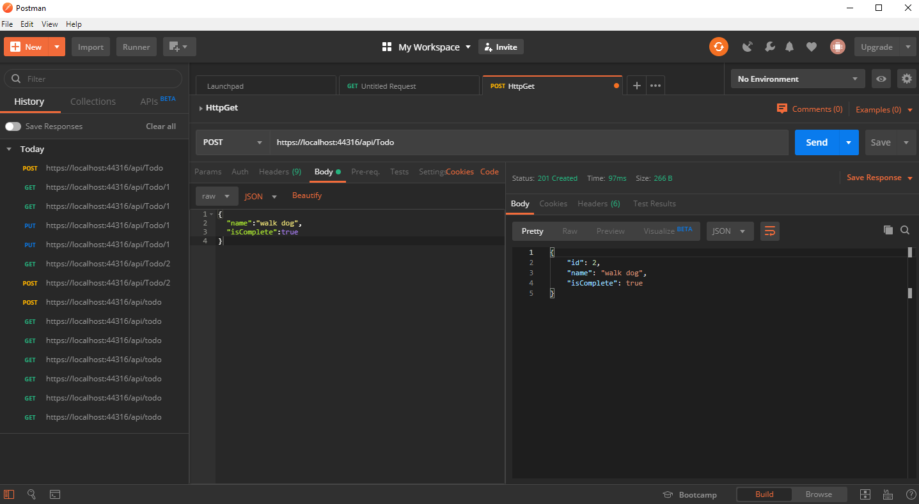

1. Using Postman, do a screen print showing a GET for the item posted from the previous exercise.

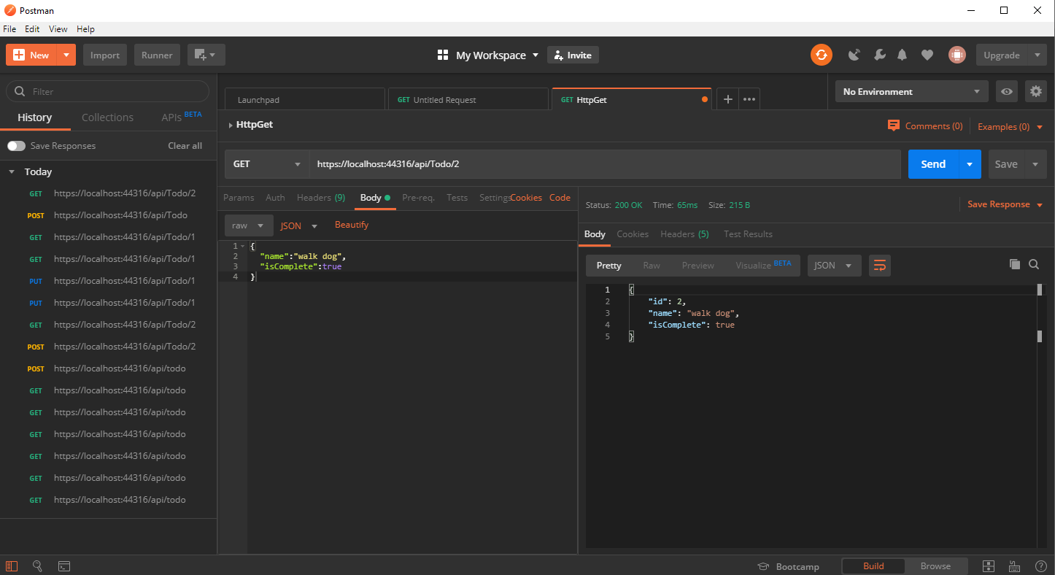

1. What status code is return for a successful PUT to the server?
2. Using Postman, do screen print showing a successful PUT of your choice.

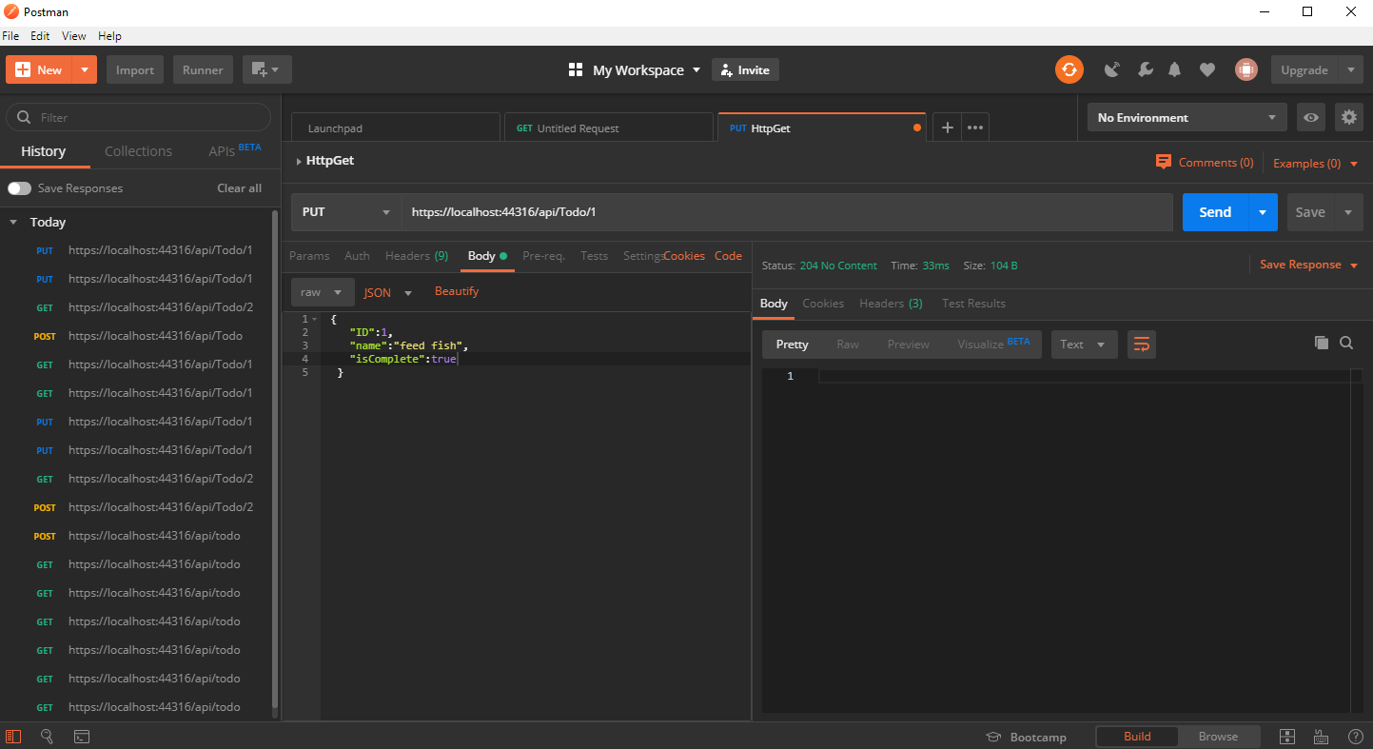

1. Using Postman, do a screen print showing a GET for the item posted from the previous exercise.

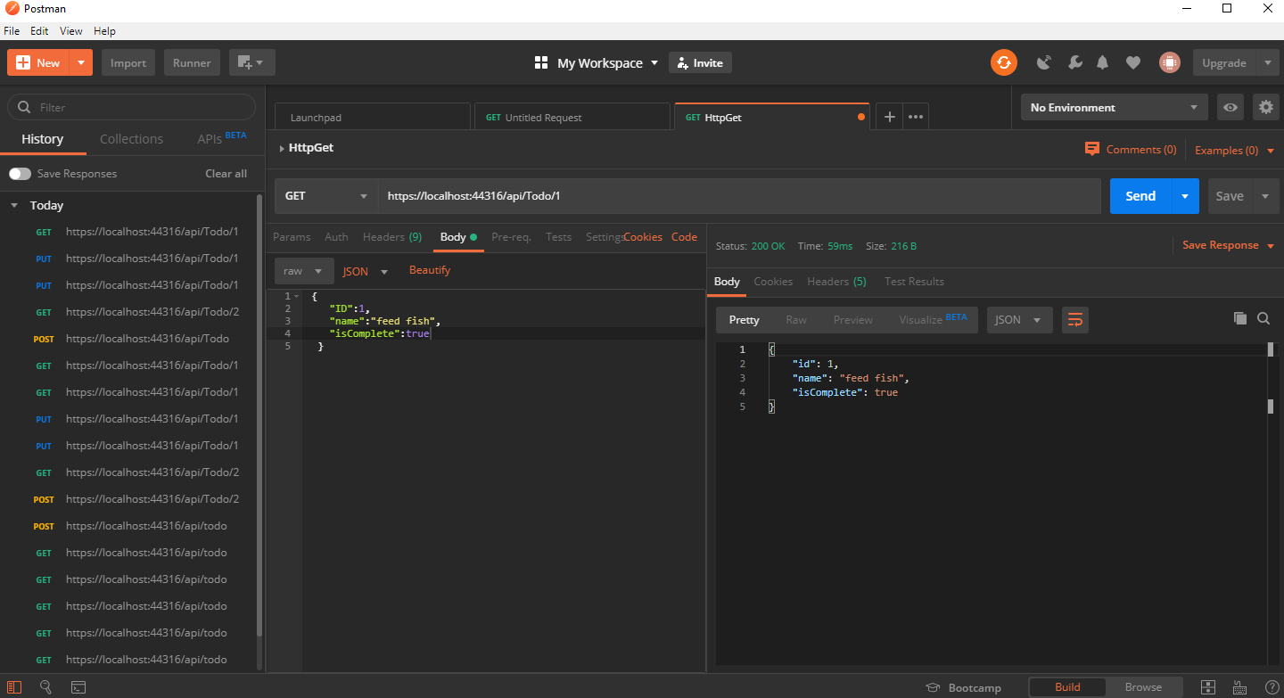

1. True or False: HTTP PUT can do partial changes.

False

1. Research and define what is meant by the term Idempotent in regards to RESTful services.

Idempotent in regards to RESTful services allow clients to make the same call repeatedly while producing the same results.